Downloading Python for Windows 10

1. Install Python for Windows ([Click here for the link](https://www.python.org/downloads/windows/))
   1. To decide between Python 2.x and Python 3.x, [I followed this article](https://wiki.python.org/moin/Python2orPython3#Should_I_use_Python_2_or_Python_3_for_my_development_activity.3F)
   2. If you have a 64-bit machine, download the Windows x86-64 executable installer
   3. Once the file is downloaded, right click on the file and selected ‘Run as Administrator’
   4. When the installer options open, select the checkbox: Add to PATH

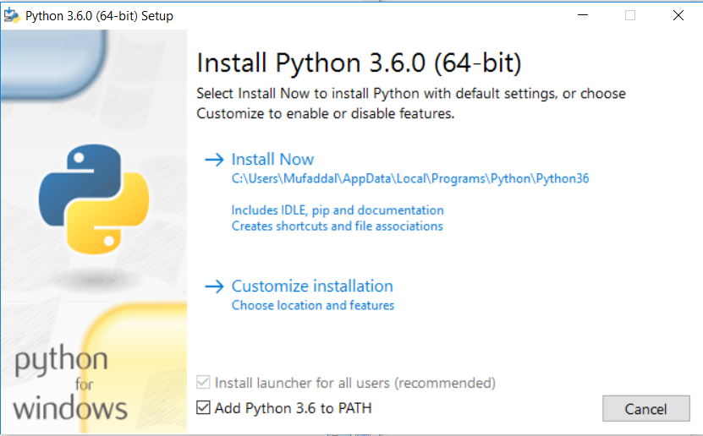

* 1. Select Install Now

1. Download Sublime Text, a text editor for code with good UI ([click here for the link](https://www.sublimetext.com/))

It is cross platform, enables spilt editing, and provides immense flexibility as settings can be specified on a per file basis

* 1. Download, and run the installer as Administrator

1. Create a Hello World Python script
   1. Create a new file in Sublime Text
   2. Select View -> Syntax -> Python
   3. Enter print statement for Hello World  
      print (“Hello World)
   4. Save file as HelloWorld.py
   5. Open Command Prompt
   6. Type: python.exe [location of file]



* 1. Take out end quote for the print statement, and save the file
  2. Run the command in command prompt again
  3. An error is displayed with the correct line number indicating the issue

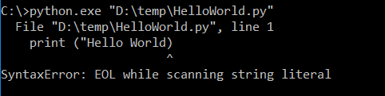

1. Download Git for Windows 64-bit machine ([Please click on this link](https://git-scm.com/download/win))
   1. Run the installer as Admininstrator

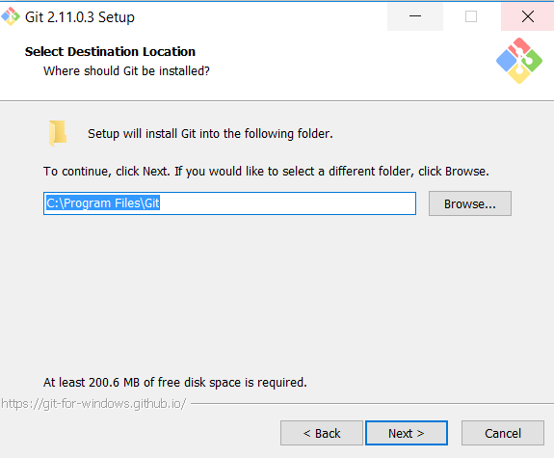

* 1. Add Git commands to your PATH variable

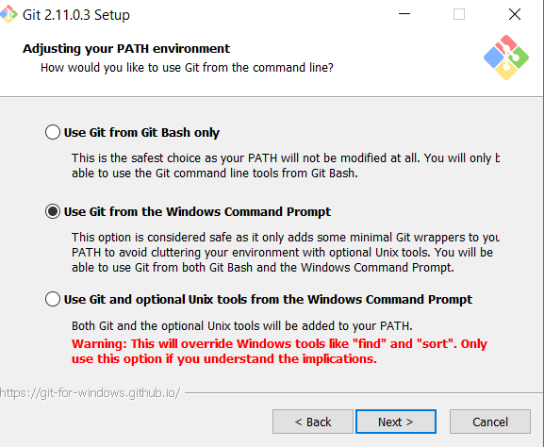

* 1. Clone and download Git Repo: compNeuroIntro420
     1. Run git bash
     2. Prepare your local repo
        1. Inititalize a repository in an existing directory

cd /d/compNeuroIntro420/

* + - 1. And type: git init
      2. Clone the course repo

git clone “https://github.com/alefiyaj/compNeuroIntro420.git”

* + - 1. A local repo is created and you are automatically on the master branch

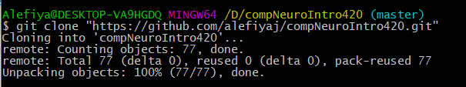

* 1. Create a new branch, commit the changes, and push the changes
     1. Create a new, local branch and switch to it

git checkout -b “assignment_wk2”

* + 1. For my change, I am adding this document to the folder to the “howTos” folder
    2. Commit changes to the local branch
    3. Check the difference between current branch and local master branch
    4. Merge the changes to the local Master branch
    5. Push the changes to the repo